1. 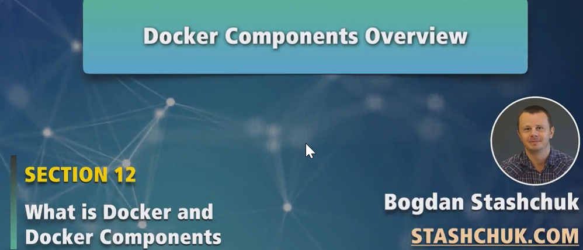
2. 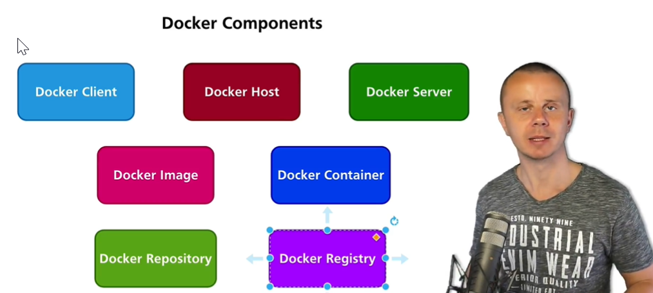
3. **Docker Client**: Used to execute Docker commands on Docker Server.   
   Actually, when you open up terminal and type Docker command, you launch Docker client.
4. **Docker Host**: Used to launch and storing containers.
   1. If we run Docker Desktop on windows or Mac OS, then Docker Host is small Linux VM machine that is running on top of windows or Mac OS Computer.
   2. If you have installed Docker on Linux computer such as on Ubuntu Server, then Ubtuntu Server is the Docker Host.
   3. **NOTE**: In nutshell, **The Linux machine is Docker Host**.
   4. **Jatin**: Where Docker Engine runs. We know Docker Engine runs on Linux Machine. So that Linux machine is Docker Server.
5. **Docker Server**:
   1. There is no such kind of single Docker Server. Basically, it’s set of different processes responsible for creation, management, and execution of different kinds of containers.
   2. Docker daemon is part of it. Docker client connects to Docker Daemon in order to send different commands.   
      Then those commands are executed afterwards by other processes in Docker Server such as **contianerd and runc** which are responsible to create and manage containers in Docker Host**.**
6. **Docker Image**:
   1. It is used to create Docker container.
   2. It’s read-only set of files.
   3. You can create your own images or you can download from Docker Hub.
7. **Docker Container**
   1. Based on some Docker Image.
   2. From Docker image, we can create multiple containers.
8. **Docker Repository**:
   1. Docker repository is a set of Docker images with different versions.
   2. We can create custom repository or we can use published repository.
9. **Docker Registry**:
   1. Place where Docker repository is stored.
   2. Most popular Docker registry in the world is **Docker Hub similar to GitHub**.   
      Github is used to store git repo.
10. There are other Docker components such as **Docker Compose**. We will talk about it later.
11. Let’s dive deep into those components in next lecture.